**Module Title**

**Internet Technologies**

**Type Portfolio Coursework**

**Year**

**2024-25**

CS & DF- L3_sem-2

**Student Name: Osama Jat**

**UWE ID: 24030174**

**Assignment Submission Date: 26-6-2024**

**Week: 1**

# World Wide Web

WHAT IS WORLD WIDE WEB?

The **World Wide Web** (**WWW** or simply the **Web**) is an information system that enables content sharing over the Internet through user-friendly ways meant to appeal to users beyond IT specialists and hobbyists. It allows documents and other web resources to be accessed over the Internet according to specific rules of the Hypertext Transfer Protocol (HTTP).

HISTORY

The World Wide Web was invented by a British scientist, Tim Berners-Lee in 1989. He was working at CERN at that time. Originally, it was developed by him to fulfill the need of automated information sharing between scientists across the world, so that they could easily share the data and results of their experiments and studies with each other.

CERN, where Tim Berners worked, is a community of more than 1700 scientists from more than 100 countries. These scientists spend some time on CERN site, and rest of the time they work at their universities and national laboratories in their home countries, so there was a need for reliable communication tools so that they can exchange information.

ISP

An ISP (internet service provider) is a company that provides individuals and organizations access to the internet and other related services. An ISP has the equipment and the telecommunication line access required to have a point of presence on the internet for the geographic area served.

WEBSITE

A website (also written as a web site) is a collection of web pages and related content that is identified by a common domain name and published on at least one web server. Websites are typically dedicated to a particular topic or purpose, such as news, education, commerce, entertainment, or social media.

TYPES OF WEBSITE

**Static Website:** In Static Websites, Web pages are returned by the server which are prebuilt source code files built using simple languages such as HTML, CSS, or JavaScript. There is no processing of content on the server (according to the user) in Static Websites. Web pages are returned by the server with no change therefore, static Websites are fast. There is no interaction with databases. Also, they are less costly as the host does not need to support server-side processing with different languages.

**Dynamic Website:** In Dynamic Websites, Web pages are returned by the server which are processed during runtime means they are not prebuilt web pages but they are built during runtime according to the user’s demand with the help of server-side scripting languages such as PHP, Node.js, ASP.NET and many more supported by the server. So, they are slower than static websites but updates and interaction with databases are possible.

**WEB SERVER**

1. On the hardware side, a web server is a computer that stores web server software and a website's component files (for example, HTML documents, images, CSS stylesheets, and JavaScript files). A web server connects to the Internet and supports physical data interchange with other devices connected to the web.
2. On the software side, a web server includes several parts that control how web users access hosted files. At a minimum, this is an *HTTP server*. An HTTP server is software that understand url (web addresses) and http(the protocol your browser uses to view webpages). An HTTP server can be accessed through the domain names of the websites it stores, and it delivers the content of these hosted websites to the end user's device.

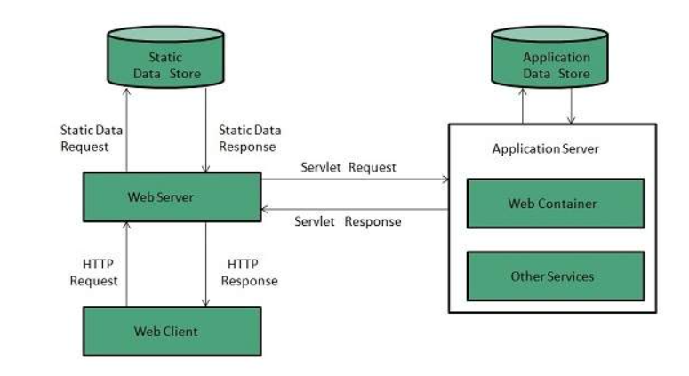

fig: web server

WEB BROWSER

A web browser takes you anywhere on the internet. It retrieves information from other parts of the web and displays it on your desktop or mobile device.

The information is transferred using the Hypertext Transfer Protocol, which defines how text, images and video are transmitted on the web.

A software application used to access information on the World Wide Web is called a Web Browser.

EMAIL

Email

Emails are delivered extremely fast when compared to traditional post. Emails can be sent 24 hours a day, 365 days a year. Webmail means emails can be sent and received from any computer, anywhere in the world, that has an Internet connection. Cheap - when using broadband, each email sent is effectively free.

Advatages Of Email

Email is a free tool. Once you are online, there is no further expense that you need to spend on in order to send and receive messages.

Email is quick. Once you have finished composing a message, sending it is as simple as clicking a button.

Email is simple. It is easy to use. Once your account is set up, composing, sending and receiving messages is simple.

Email allows for easy referencing. Messages that have been sent and received can stored, and searched through safely and easily. It is a lot easier to go through old email messages rather than old notes written on paper.

Email is accessible from anywhere – as long as you have an internet connection. Whether or not you are in the office or on the field, or even overseas, you can access your inbox and go through your messages.

Email is paperless, and therefore, beneficial for the planet.

Email allows for mass sending of messages. An effective medium to utilize to get your message out there, you can send one particular message to several recipients all at once.

Email allows for instant access of information and files.

**Types of E-mail**

**Client based e-mail**

An email client is a software application that is used to access, manage, and send emails. It provides users with a user interface that allows them to view and organize their email messages. Email clients can be standalone applications, web-based applications, or mobile applications.

Client-based email

**Username: This is usually just the first part of your email address.**

**- Password: Your password corresponding with your Username.**

**- Email Address: A valid email address looks like this:**

**user1@wlink.com.np.**

**- POP3 Server Address: This is the address we need to configure to get**

**your incoming mail. It typically looks like this: mail.your-isp.net**

**- SMTP Server Address: This is the address we need to configure to get**

**your outgoing mail. It typically looks like this: smtp.your-isp.net or**

**mail.your-isp.net**

**- If you configure the client program properly, you can send and receive**

**email messages through your client program from your computer.**

**Web-based email**

The term Webmail (or Web-based email) is used to describe two things. One use of the word is to describe a Webmail client: an email client implemented as a web application accessed via a web browse.

A Typical Mail Environment  
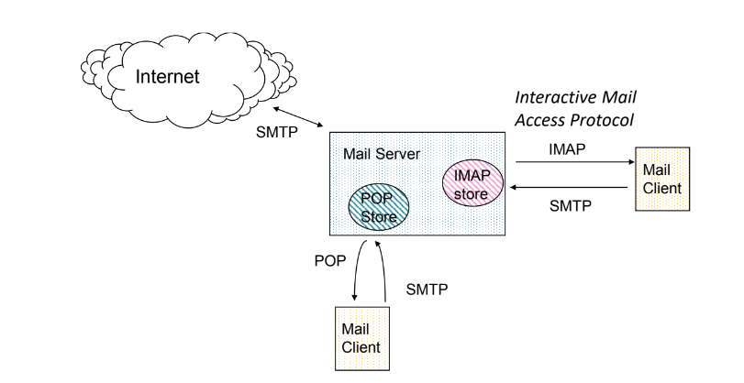

SMTP

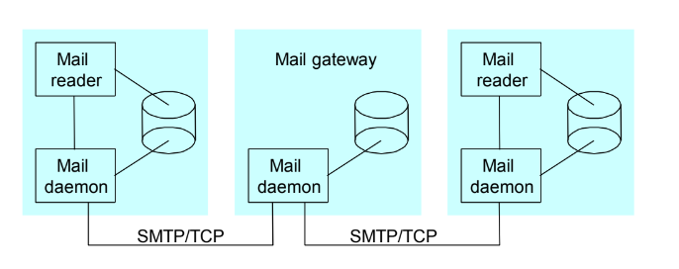  
  
  
  
  
  
Simple mail transfer protocol (SMPT)

The Simple Mail Transfer Protocol (SMTP) is a technical standard for transmitting electronic mail (email) over a network. Like other networking protocols, SMTP allows computers and servers to exchange data regardless of their underlying hardware or software. Just as the use of a standardized form of addressing an envelope allows the postal service to operate, SMTP standardizes the way email travels from sender to recipient, making widespread email delivery possible.

Post Office Protocol

Post Office Protocol (POP) is a type of computer networking and Internet standard protocol that extracts and retrieves email from a remote mail server for access by the host machine.

POP3

Post Office Protocol 3, or POP3, is the most commonly used protocol for receiving email over the internet. This standard protocol, which most email servers and their clients support, is used to receive emails from a remote server and send to a local client.

POP3 (Cont.)

- Two modes:

◦ Delete mode – mails deleted as they are read.

◦ Keep mode – mails remain in the mailbox.

- POP3 has commands for:

◦ Log in

◦ Log out

◦ Fetch messages

◦ Delete messages

IMAP4

IMAP4 was designed to solve many of the limitations of POP3. With IMAP4, mail arrives in an IMAP4 server (usually at your ISP or on a local server such as VPOP3). The email messages are put into an Inbox folder in a mailbox on the server. Then, an email client (eg Windows Live Mail, Mozilla Thunderbird or a mobile phone etc) will log into the IMAP4 server and synchronise with the server.

FTP

**FTP** is a standard network protocol used for the transfer of files from one host to another over a TCP-based network, such as the Internet.

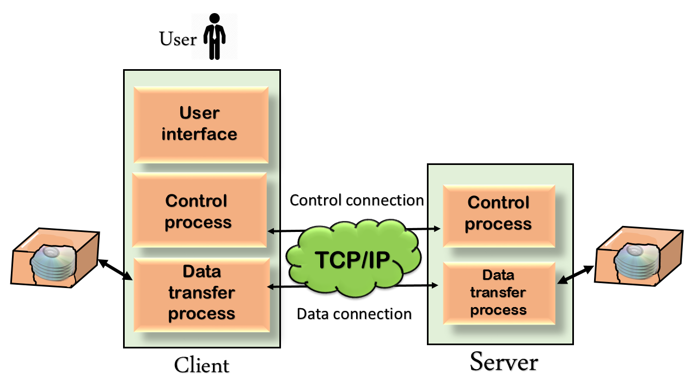

ftp:fig

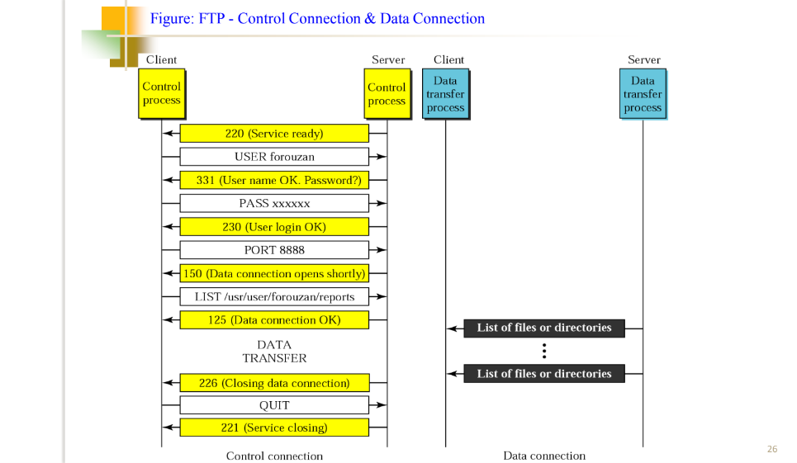

Figure abobe shows an example of using FTP for retrieving a list of

items in a directory.

1. After the control connection to port 21 is created, the FTP server

sends the 220 (service ready) response on the control

connection.

2. The client sends the USER command.

3. The server responds with 331 (user name is OK, password is

required).

4. The client sends the PASS command.

5. The server responds with 230 (user login is OK)

6. The client issues a passive open on an ephemeral port for the

data connection and sends the PORT command (over the control

connection) to give this port number to the server

7. The server does not open the connection at this time, but it

prepares itself for issuing

8. The client sends the LIST message.

9. ow the server responds with 125 and opens the data

connection.

10. The server then sends the list of the files or directories (as a

file) on the data connection. When the whole list (file) is sent,

the server responds with 226 (closing data connection) over the

control connection.

11. The client now has two choices. It can use the QUIT command

to request the closing of the control connection or it can send

another command to start another activity (and eventually

open another data connection). In our example, the client

sends a QUIT command.

12. After receiving the QUIT command, the server responds with

221 (service closing) and then closes the control connection.

HTTP

The Hypertext Transfer Protocol (HTTP) is the foundation of the World Wide Web, and is used to load webpages using hypertext links. HTTP is an application layer protocol designed to transfer information between networked devices and runs on top of other layers of the network protocol stack.

HTTP - methods

 Methods

◦ GET

 retrieve a URL from the server

 simple page request

 run a CGI program

 run a CGI with arguments attached to the URL

◦ POST

 preferred method for forms processing

 run a CGI program

 parameterized data in sysin

 more secure and private

HTTP packets

The HTTP package is conditionally compliant with RFC 2616. It includes support for: Persistent connections and pipelined requests with HTTP/1.1 servers. Interpretation of chunked-data responses from HTTP/1.1 servers. Requesting part of an HTTP document.

Status Header

 “HTTP/1.0 sp code”

 Codes:

◦ 1xx - reserved for future use

◦ 2xx - successful, understood and accepted

◦ 3xx - further action needed to complete

◦ 4xx - bad syntax in client request

◦ 5xx - server can’t fulfill good request

Status Codes

 200 OK

 201 created

 202 accepted

 204 no content

 301 moved perm.

 302 moved temp

 304 not modified

 400 bad request

 401 unauthorized

 403 forbidden

 404 not found

 500 int. server error

 501 not impl.

 502 bad gateway

 503 svc not avail

Statelessness

 A stateless person is someone who, under national laws, does not enjoy citizenship – the legal bond between a government and an individual – in any country.